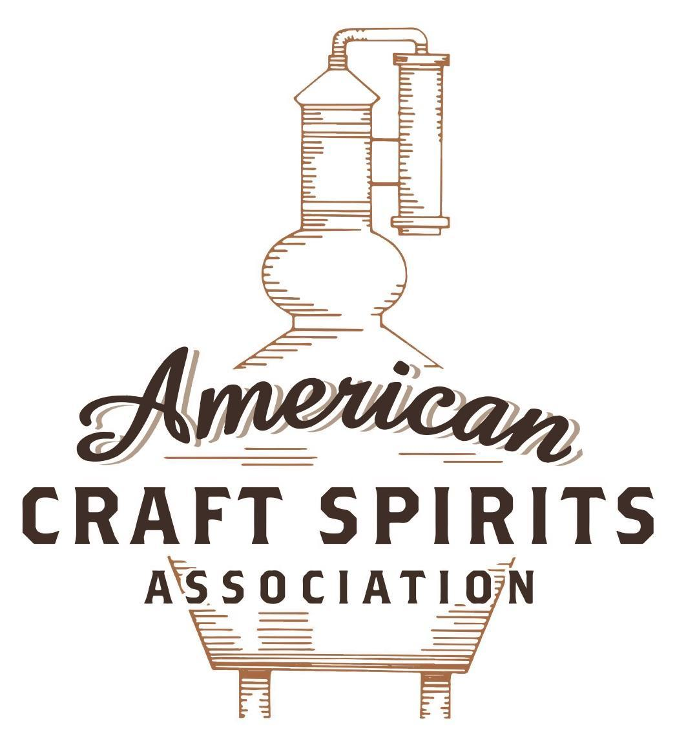
Spirits DtC Shipping Guide

This guide summarizes the direct-to-consumer shipping rules for distilleries in all 50 states and D.C. and also addresses the measures state governments have taken to ease delivery and shipping restrictions during the COVID-19 pandemic.

DtC Quick Guide Comparison

Out-of-State Distilleries  Can Ship Into State? |  |  |  | In-State Distilleries  Can Ship Within State?
State | Yes | No |  | State | Yes | No
AL |  | X |  | AL |  | X
AK | X |  |  | AK | X
AZ | X |  |  | AZ | X
AR |  | X |  | AR |  | X
CA |  | X* |  | CA |  | X*
CO |  | X |  | CO |  | X
CT |  | X* |  | CT |  | X
DE |  | X |  | DE |  | X
DC | X |  |  | DC | X
FL |  | X |  | FL |  | X
GA |  | X |  | GA |  | X
HI |  | X* |  | HI |  | ?*
ID |  | X |  | ID |  | X
IL |  | X* |  | IL |  | X*
IN |  | X |  | IN |  | X
IA |  | X* |  | IA |  | X*
KS |  | X |  | KS |  | X
KY | X |  |  | KY | X
LA |  | X |  | LA |  | X
ME |  | X* |  | ME |  | X*
MD |  | X |  | MD |  | X
MA |  | X |  | MA |  | X
MI |  | X |  | MI |  | X
MN |  | X |  | MN |  | X
MS |  | X |  | MS |  | X
MO |  | X |  | MO |  | X
MT |  | X |  | MT |  | X
NE | X |  |  | NE | X
NV |  | X* |  | NV |  | X
NH | X |  |  | NH |  | X*
NJ |  | X* |  | NJ |  | X*
NM |  | X |  | NM |  | X
NY |  | X* |  | NY |  | X*
NC |  | X |  | NC |  | X
ND | X |  |  | ND | X
OH |  | X |  | OH |  | X
OK |  | X |  | OK |  | X
OR |  | X |  | OR | X
PA |  | X* |  | PA |  | X
RI |  | X* |  | RI |  | X
SC |  | X |  | SC |  | X
SD |  | X |  | SD |  | X
TN |  | X |  | TN |  | X
TX |  | X |  | TX |  | X
UT |  | X |  | UT |  | X
VT |  | X |  | VT |  | X
VA |  | X |  | VA |  | X
WA |  | X* |  | WA | X
WV |  | X* |  | WV |  | X*

WI |  | X |  | WI |  | X
WY |  | X |  | WY |  | X

Notes:
*CA: If passed and signed into law, Senate Bill 620 would allow licensed distilled spirits producers in states other than California and licensed distilled spirits manufacturers or craft distillers in California who obtain distilled spirits direct shipper permits to ship directly to consumers in California
*CT: Consumers with appropriate permit may receive alcohol shipments
*HI: Consumers with appropriate permit may receive alcohol shipments; If passed and signed into law, Senate Bill 65 would allow licensed distilled spirits manufacturers in Hawaii and in states other than Hawaii who obtain direct shipper permits to ship directly to consumers in Hawaii
*IL: If passed and signed into law, Senate Bill 0532 would allow licensed distilled spirits producers in Illinois and in states other than Illinois who obtain distillery shippers’ licenses to ship directly to consumers in Illinois
*IA: If passed and signed into law, House File 639 would allow native distilled spirits manufacturers in Iowa and in states other than Iowa who obtain direct shipper permits to ship directly to consumers in Iowa and to consumers in states other than Iowa
*ME: If passed and signed into law, Legislative Document 1358 would allow distilleries outside of Maine with current manufacturer licenses and distilleries licensed in Maine who obtain spirits direct shipper licenses to ship directly to consumers in Maine
*NJ: (1) If passed and signed into law, Assembly Bill 3167 would allow a craft distillery licensees to ship no more than 9 liters of distilled spirits to a consumer in New Jersey; (2) If passed and signed into law, Senate Bill 3020 would allow craft distillery licensees in New Jersey or in states other than New Jersey to ship no more than 20 liters of distilled spirits to a consumer in New Jersey via common carrier
*NV: Licensed individuals can import one gallon per month of spirits for personal use and the out-of-state supplier must pay excise tax
*NH: If passed and signed into law, Senate Bill 125 would allow licensed liquor manufacturers who obtain direct to consumer shipping permits from the commission to ship directly to consumers in New Hampshire
*NY: Consumer may import up to 90L of liquor per year for personal use without a license; If passed and signed into law, Assembly Bill 3275 would allow licensed liquor manufacturers in states other than New York and licensed distillers and farm distillers in New York to ship no more than thirty-six cases (no more than nine liters per case) of liquor to consumers in New York
*PA: Consumer may place a special liquor order and distiller must ship to a PLCB-operated store
*RI: Distiller can only ship to customer if order was personally placed by customer at distiller's premises
*WA: If passed and signed into law, House Bill 1432 would allow licensed spirits manufacturers in states other than Washington to ship spirits to consumers in Washington
*WV: Distilleries, mini-distilleries, or micro-distilleries licensed in West Virginia or a state other than West Virginia who obtain private direct shipper licenses to ship to a consumer in West Virginia, however the shipments must be made to a retail liquor outlet

ALABAMA

Shipment Outbound – Yes, if permitted by purchaser’s applicable laws (AL Code, Section 28-4-113).
Shipment Inbound – No (AL Code, Sections 28-4-110 & 111).
Shipment Intra-state – No, but licenses issued by the Alabama Alcoholic Beverage Control Board, in accordance with § 28-3A-23, authorize licensees to transport and deliver spirits to individuals in the state who are at least 21 years of age. Any entity licensed for off-premises consumption, restaurant licensee, or reputable organization that is registered to do business in Alabama may apply for and be issued a delivery service license. A delivery must be made in a vehicle that is owned or leased by the delivery service licensee or an employee or independent contractor of the licensee. A delivery service licensee may not deliver alcohol more than 75 miles from the licensed premise of the retail licensee where the delivery originated. The total amount of spirits delivered cannot exceed 9,000 milliliters per customer in any single 24-hour period.
Link: http://alisondb.legislature.state.al.us/ALISON/SearchableInstruments/2021RS/PrintFiles/SB126-enr.pdf
COVID-19 Measures – Emergency rule 20-X-6-.19ER did not authorize direct shipment of alcohol to AL residents, but allowed licensees to sell off-premises via curbside pick-up or take-out. This measure was effective from December 14, 2020 to January 4, 2021.
Citation (shipment)
AL Code
Section 28-4-110 Carriage, delivery, etc., into state by common carrier, etc., of prohibited liquors and beverages generally.
It shall be unlawful for any common or other carrier or any other person, corporation or association or combination of persons to carry, bring or introduce into this state or to deliver to any person whomsoever in this state any of the prohibited liquors and beverages as defined by the laws of the State of Alabama in any quantity whatsoever, whether in original packages or otherwise and although brought from a point without the State of Alabama.
Link: http://alisondb.legislature.state.al.us/alison/codeofalabama/1975/28-4-110.htm
Section 28-4-111 Receipt or acceptance from common carrier, etc., of prohibited liquors or beverages generally.
No person shall receive or accept any prohibited liquors or beverages from a common carrier or other carrier, except alcohol in accordance with regulations and restrictions of the laws of Alabama and for the purposes prescribed by said laws and except wine for sacramental or religious purposes as permitted under law and then only if there is permanently pasted or attached to the container a copy of the prescription or affidavit upon authority of which it was prescribed or obtained.
Link: http://alisondb.legislature.state.al.us/alison/codeofalabama/1975/28-4-111.htm
Section 28-4-113 Acceptance for or shipment, transportation, delivery, etc., of prohibited liquors or beverages from point to point or along public streets or highways within state.
It shall be unlawful for any person, firm, corporation or association, whether a common carrier or not, to accept from another for shipment, transportation or delivery or to ship, transport or deliver for another said prohibited liquors or beverages or any of them when received at one point, place or locality in this state to be shipped or transported to or delivered to another person, firm or corporation at another point, place or locality in this state, or to convey or transport over or along any public street or highway any of such prohibited liquors for another. The provisions of this section shall not apply to those transporting and delivering to the persons, firms or corporations authorized by law to receive said prohibited liquors or beverages or any of them. Any person violating any provision of this section shall be guilty of a misdemeanor.
Link: http://alisondb.legislature.state.al.us/alison/codeofalabama/1975/28-4-113.htm
Citation (COVID-19)
ABC Board Administrative Code
20-X-6-.19ER. EMERGENCY CURBSIDE SALES AUTHORIZATION
This emergency rule involves the suspension of the requirement for all sales to occur inside of a building on the licensed premises. Authorization of delivery or direct shipment of alcohol to consumers would require a change in the state law and requires legislative action.

An Alabama licensee who holds a Restaurant and Retail Liquor license that allows the sale of alcoholic beverages for on-premises consumption only may now sell for off-premises consumption using curbside pick-up or take-out services with the following restrictions:
b) The licensee may sell no more than one .375 liter (375 ml) bottle of spirits per customer.
(i) Spirits may be sold in any size bottle(s), provided that the total amount of the spirits sold does not exceed
.375 liter (375 ml) per customer.
Link: https://alabcboard.gov/sites/default/files/inline-files/ABC%2020-X-6-.19%20ER%20%28004%29.pdf

The American Craft Spirits Association (ACSA) is working diligently to give our members and industry partners relevant, current updates on statutes and regulations impacting production, sale and distribution of spirits. With the declaration of the novel coronavirus (COVID-19) in early 2020, many states have issued temporary policy changes or longer-term modernization of alcohol beverage laws. State statutes, regulations created by the state alcohol regulatory authority, as well as any other relevant guidance provided by such authorities (such as advisories, opinions, bulletins, etc.) were reviewed in creation of this document. No city or county ordinances were reviewed. Distillers should be aware that even in states where direct shipping is permissible, always remember to avoid shipping to dry counties. Please consult with your state guild or alcohol beverage authority for the most up-to-date information. This content is intended for educational and informational purposes only. ACSA's pro bono law firm of Malkin Law P.A. provided the core content found in this comprehensive overview of the spirits distribution after COVID-19. It was completed in August 2021 and will be updated regularly. If you have updates you would like to provide, please send to legislation@americancraftspirits.org or directly to the law firm at: ryan@malkin.law / malkin.law. Thank you.

